E-commerce web based Pharmacy application fully build on JavaScript For Uzbekistan

1st Timur Tursunboev
Computer Engineering
OneTech
Busan, South Korea
timur2322727@gmail.com
2nd Abdulaziz Sirojiddinov
Computer Engineering
OneTech
Busan, South Korea
asirojiddinov96@gmail.com
3rd Jakhongirmirzo Tojimamatov
Computer Engineering
line 3: OneTech
Busan, South Korea
jtojimamatov@mail.ru

Abstract - nowadays, e-commerce has widely expanded rapidly over the past decade. And it is predicted to continue at this rate or even accelerate because it allows consumers to exchange goods and services with no barriers of time or distance. Additionally, it is often faster, cheaper and more convenient than the traditional methods of commerce. It is clear to see that E-commerce is an area of success in the field of start-up business project. The role of pharmacy in E-commerce market is young growing model of internet based business. Several developed countries are putting in practice e-pharmacy stores between manufacturers and retailers. For this purpose the need of e-pharmacy stores in society makes us to create easy to use online pharmacy web application. This paper provides detailed explanation of our E-pharmacy project and the result of the entire project will show the website has a good support for people’s lifestyle and very good support for documentation. From these results the main conclusion will be derived in order to get basic thoughts of project.
Keywords—E-commerce Pharmacy, style

Introduction

Yesterday’s fiction today’s reality, influence of communication technologies results in crucial transformations human lifestyle. By following this the word “e-commerce” is booming, it is because of these transformations is related to changes in shopping style. The word e-commerce is vide spreading and covering almost all fields that used in our daily lifestyle needs. Rather than going to store to buy some item it is now available buy this item from online store[1]. E-commerce websites have changed the way of reading, buying, selling and other things. Even nowadays we can buy medicines also online.

Online pharmacy is young growing and prospective profitable e-commerce business. It makes one of the successful online market expansion through the redaction geographical barrier. Buying from E-pharmacy stores is cheaper and time winning. it will be much comfortable E-pharmacy store based website is now our main project that we are going to do. This paper will describe firstly, main functionalities of the website.

Method
- In these days, big projects need doing surveys in order to collect data and improve their quality. We also wanted to do survey between pharmacy companies and pharmacies in Namangan region of Uzbekistan. The questioner for the survey was asking the director of the pharmacy companies and pharmacies by making a meetings one by one. The purpose of the survey was as the following two steps:
1) To know the need and requirements to develop an e-pharmacy website for buying and selling remedy online;
2) To identify tendency of the consumers (pharmacies) and sellers (pharmacy companies) towards online pharmacy website;
For the purpose of perform the survey our volunteer asked comprising of both retailers selling remedy offline in Uzbekistan and big medicine companies that situated in Namangan city (one of the twelve regions of Uzbekistan).
The result of the survey will be announced via Google drive (in the form of graphs) for further analysis. The information generated from the questioner is helpful to design and implement an electronic pharmacy website for buying and selling remedies online.

- Materials and architecture of e-pharmacy website
Let’s start by giving information about architecture of e-pharmacy website. The actual work is depending on the principles of e-commerce [2, 3]. Electron commerce based for selling and buying medicine online is developing and it was called as “E-commerce Pharmacy”. Since the project the requirement and technology for the realization of the project were very clear and fixed the waterfall model was used for developing the e-commerce pharmacy website. The linear sequential cycle of the website model consisted of four main steps:
1) Survey (data collection) for the analysis;
2) Design the framework of the website;
3) Implementation the interface and database of the website using Node.js (computer program language) and MongoDB server;
4) Testing and checking the bags by running our website.
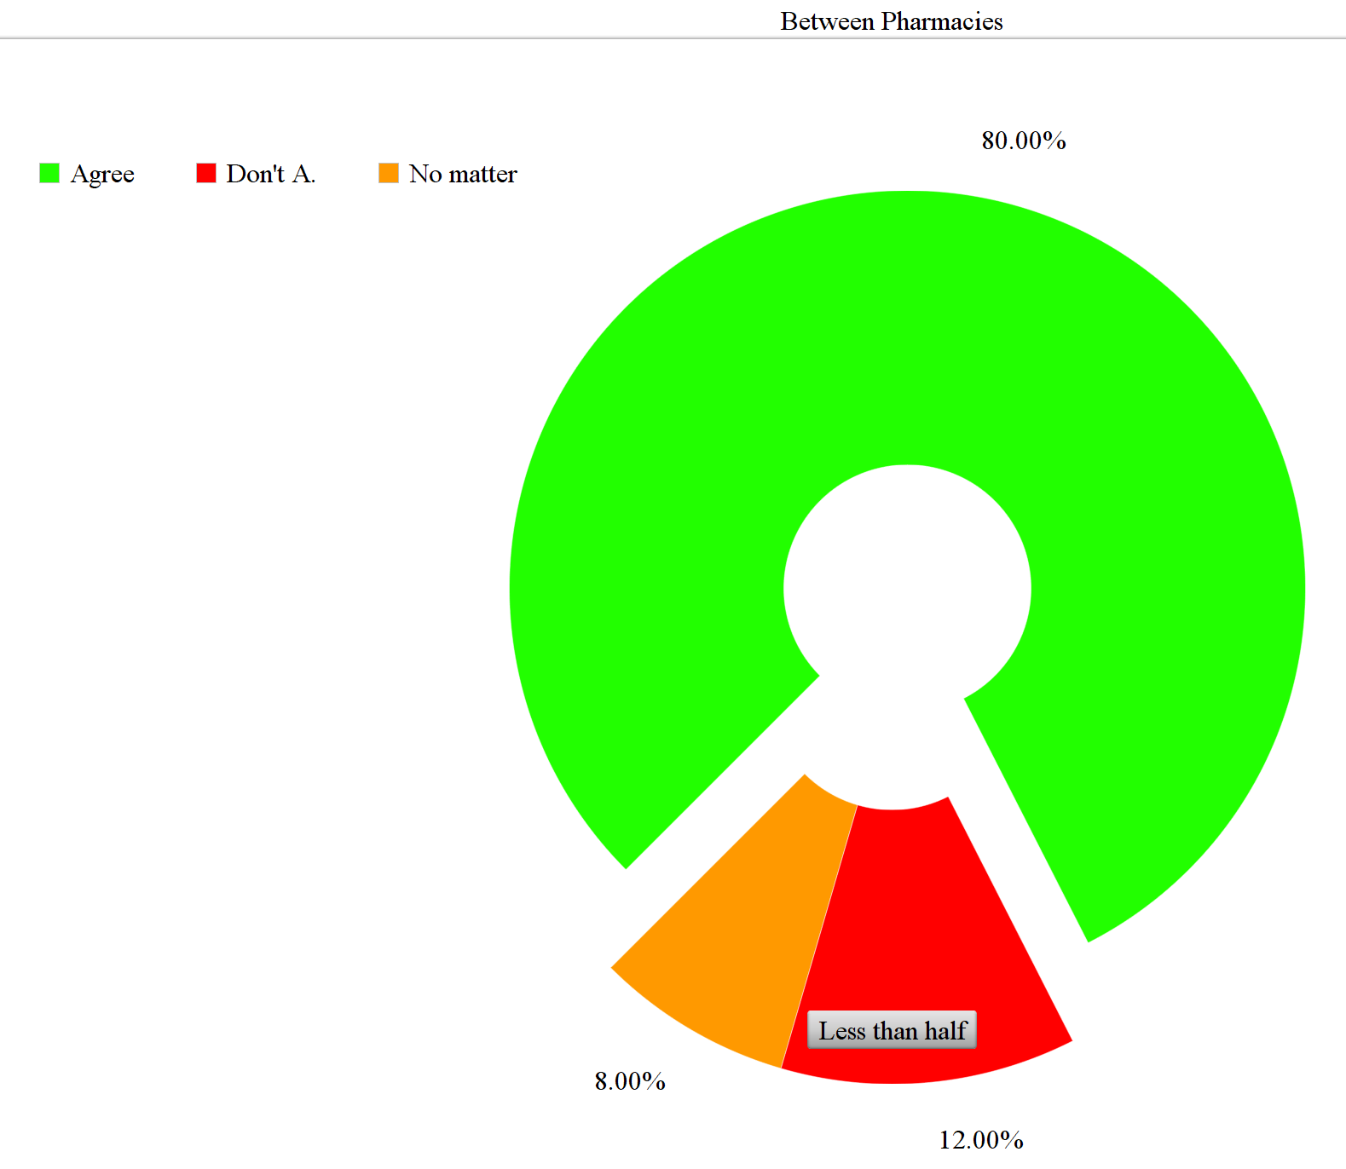
Fig. 1. Survey results between Pharmacies.
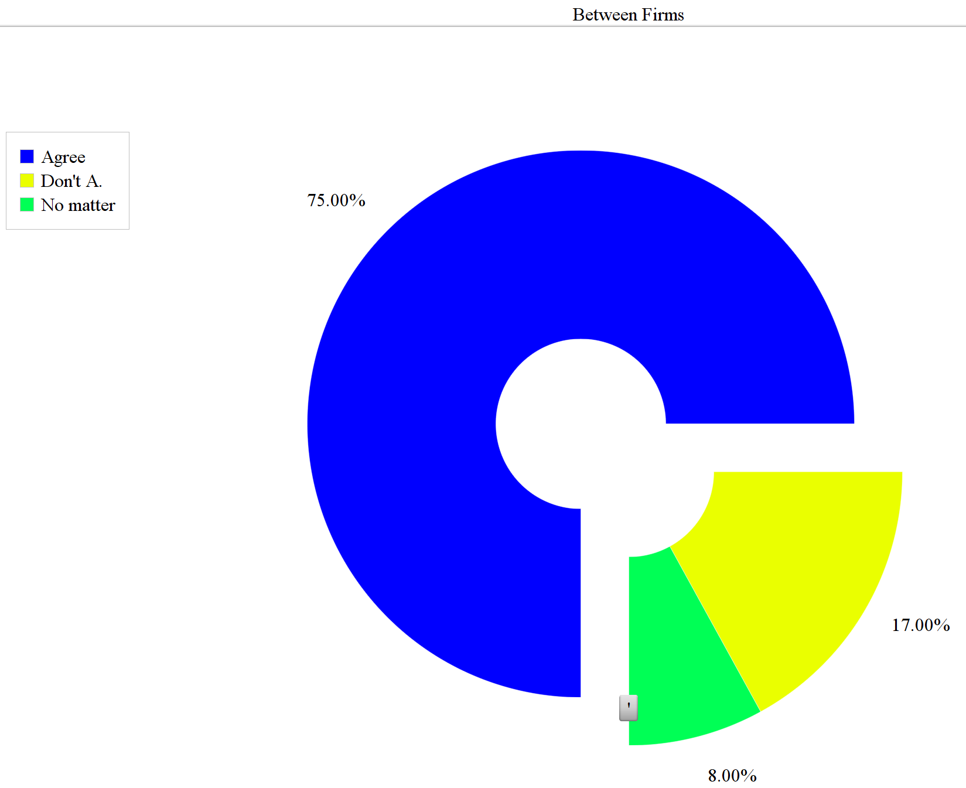
Fig. 2. Survey results between Firms
In today’s world, it is very important to doing survey between costumers before running your business. Thus, we also did survey between pharmacies and pharmacy companies. In our survey, there were some minor questions but main purpose was using e-commerce in pharmacy field. And we divided them into three groups. First one is “agree”, second one is “do not agree”, and the last one is “no matters”.
- First survey was between pharmacies (Fig. 1).
80% of pharmacies were agree to our project. And, the level of pharmacies, which were disagree, illustrated about 12%. The lowest percentage recorded by neutrals with only 8% (survey was among over 120 pharmacies in Namangan region).
- The second survey for knowing pharmacy
companies’ opinion about running our website (Fig. 2). Most of them agreed to run our e-commerce website (75%). The percentage of neutrals was 8%. Lastly, 17% of pharmacy companies did not agree to run this website (survey was among 37 pharmacy companies in Namangan region).

This section is about materials that we are using. Every programmer use suitable program to make different websites. For example: HTML, CSS, JavaScript, React.js and so on. HTML document contains a variety of tags with corresponding attributes, and the tags are separated into tag and pairs tag. It is common tool to make a website. Suitable tools for us Node.js, MongoDB, HTML, CSS, React.js is a JavaScript library from each side as designing and for building user interface.
In this paragraph, we want to give brief information about some of our main used programs as Node.js – Express Framework that we used in our project. Express is a minimal as well as flexible Node.js web framework that can provide a robust number of features to develop website and mobile apps. It gives a chance to set up middleware to respond to HTTP requests. And, it can render HTML Pages dynamically based on passing arguments to templates.
Mongo DB is the most popular database type in these days because of NoSQL and no need to make a table as a MySQL. Besides, it is open-source document-oriented database and additionally [4], it is being used as a beck end for many websites.
Stripe is online method of payment and it put a payment platforms together with applications [5]. In addition to these, stripe is a third party application.
Another main part of website is the template engine is like bridge between Database and front end to show data. Template engine which is connection between Databases combined with Web Template is code to Document. Typically, the template engine contains:
- Variables and functions
- Text replacements
- Conditions and include lists of elements
- Inclusion of files [6]

There are many types of chemistry e-commerce as business-to-business (only chemistry shops can buy the medicine from that chemistry e-commerce); business- to –customer (ordinary people also can buy the medicine from that chemistry e-commerce); customer-to- customer (any person can post the unnecessary medicine in that chemistry e-commerce); our web-site will use these kinds of e-commerce strategies.

- E-commerce pharmacy website implementation
- This section introduces Website Login Page
The new user cannot browse the site without sign in and need to register from the Login page to receive a verification code and then the user can login with the help of a unique username and password as highlighted in Fig.1.

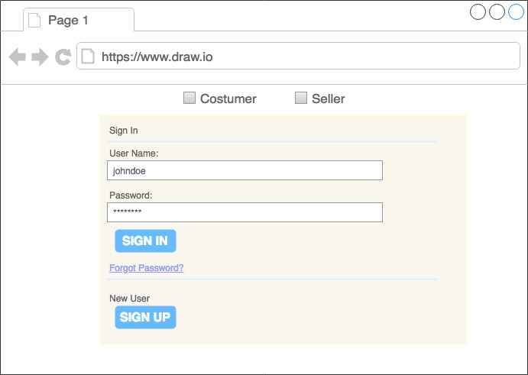
Fig. 3. Shows E-commerce Pharmacy Login page

- Furthermore, our second page is for searching remedy and selecting city with seller (main page)
After login successfully, in the home page (in Fig. 2), there is a slider which is a blank for the advertisement. There will be only new or seasonal remedies. User should select their own location in the City section before searching remedy and they can choose Seller Company, if they want. Below the slider blank, there is a search section. User can search for medicine. Customer browses through compare section and they can see the companies’ remedy price. Customer can select items to buy by seeing difference of prices. If user wants request for the amount of product, the user should click to the Order Button.
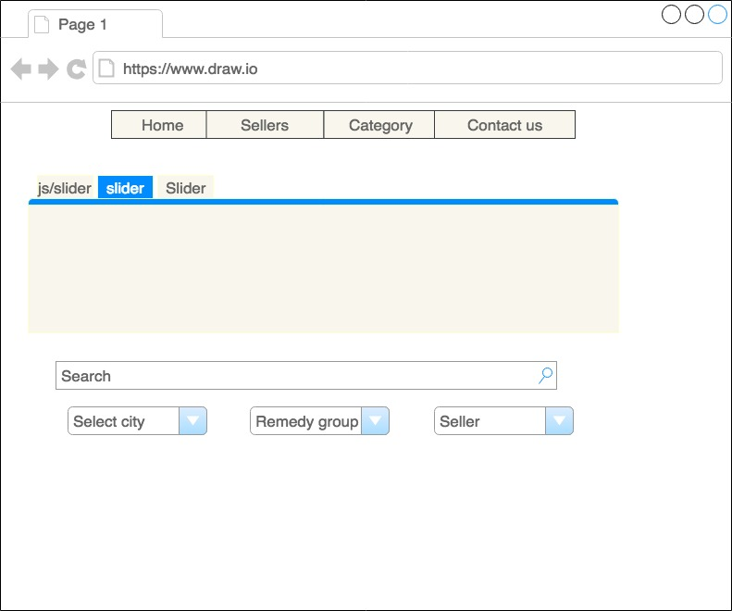
Fig. 4. Shows that how customer can search medicine from our webpage.

- E-pharm website design
- About Use case diagram for sign in for e-commerce pharmacy website
The functional requirement of the website login page was centered on the registering users to do their business easier and more comfortable (e-commerce). In this case, the use case diagram was utilized to model of the action typically describing the correlations between the system (e-pharm website) and the admin, users as presented in Fig 3.
There are two actors namely server and user in the use case diagram of e-pharm website. And user should choose the sign of the Buyer or Seller. Sign up is for users to make their own profile. The link sign in is available after sign up. In the link of sign in, user should write username and password. If user forgets the password the user should click “forgot password” and then our system will send a secure code via Mail / Phone number to recover the password.
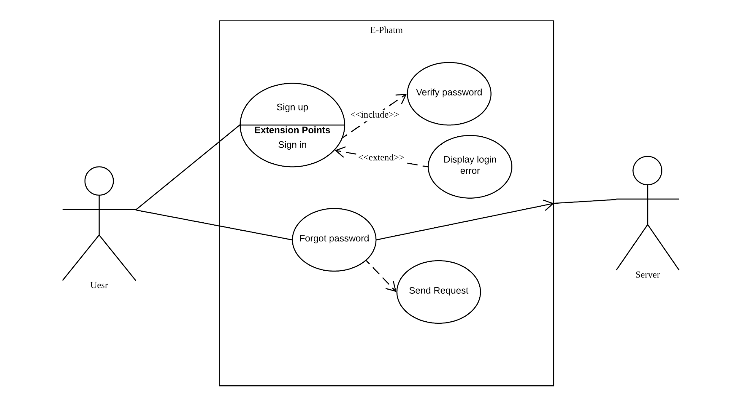
Fig. 5. Represents connection between user and server (to login)

- Use case diagram for main page
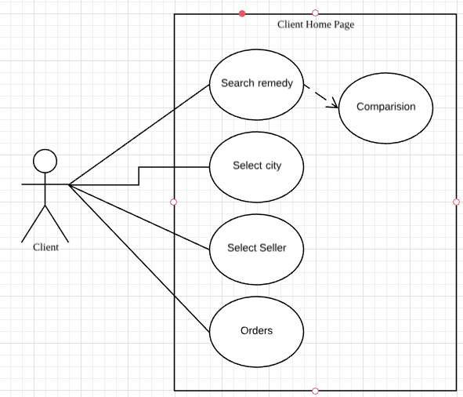
Fig. 6. Shows what user can do on the main page

As shown in Fig 4, the use case diagram of the E-pharm website consists of more than 5 use cases. And it shows that user can search medicine and comprise prices between pharmacy companies. There are more options to the users; they can select the city where they wanted to buy and which company they want to buy medicine. Lastly, user can see his or her history orders by clicking Orders.

Experiments
- Search engine
In the E-commerce website, Search engine is the most important part. Nowadays, many people do not want to look for stuffs in more times. Thus, at that situation clients rely on search engines to find information about everything easily. Setting the search item can improve the quality of the website between other ones. In these days. Google and Yahoo are like librarians of the Internet, their system collect information about each page on the web to make a convenience people to find exactly what they are looking for. Besides, every search engine has algorithm to get search result. In that situation SEO stands for Search engine optimization helps us by looking at the title of the book which we search or links are connected to another one and in addition to these, SEO can count words which look for. Using SEO is going up among many software companies. There would be a question like that “what is SEO” and the answer is that the SEO is a combined method to improve the site’s level as Google [7]. Besides, it converts the traffic into leads and customers. There are several benefits of SEO to make things a little clearer as there are three advantages of it:
- Attract qualified traffic – by using this one, we can avoid people to be annoyed by the ads
- Earn a high return on investment - in this part, only one created page can keep going that attracting consumers
- Achieve a high click through rate – via clicking on an organic result on the first page, we can earn fraction of the clicks and then, it gives us a chance to attract users much more.
Another advantage side of SEO is that it does not require payment for ad space and then programmer can make a position for the location. 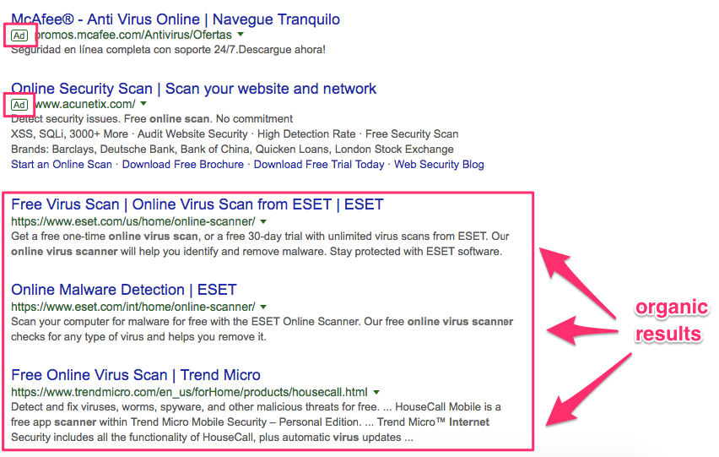
Fig. 7. Example of using SEO
[8].
If we look at our website, we can use search engine too to make a convenient way for users in order compare products without any difficulty and to find the product which they want.
Our website is associated with local marketing. When people access to our website, there is a search engine function. This search engine provides the chance to search remedies which users need. By searching a certain kind of remedies, the users can also get information about remedies and prices according to their location. Moreover, it also shows a comparison of remedy prices due to the location.

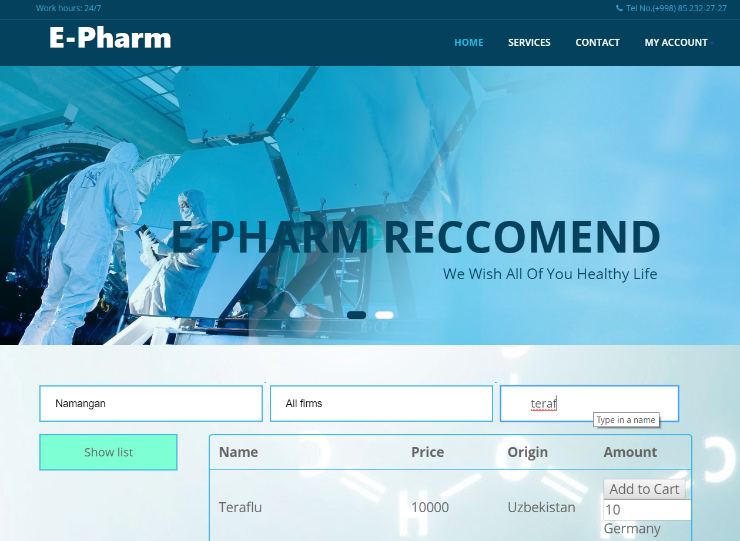
Fig. 8: Main page of customers
B. Order and Delete functions
People who use e-commerce website are more familiar with an order function. The order has an electronic storage for make a catalog about products what users selected to order. If consumers want to buy all of products which they selected, they can transfer money for the product via the seller’s bank account. In case, users do not want to get these products, there is delete function too for removing some medicines.

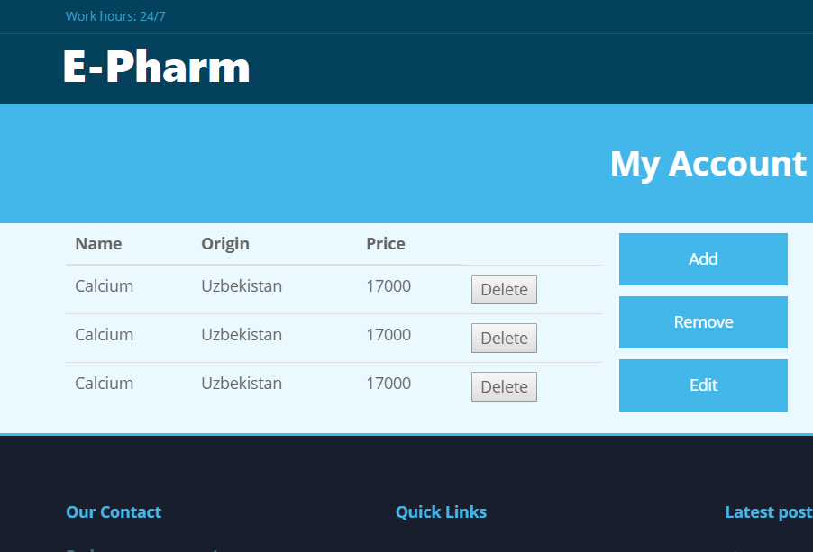
Fig. 9: Seller’s account page

IV. Related-Work
A. Comparison of Home18Shop.com with E-pharm
There are a lot of e-commerce websites all over the world. In most cases, most of websites cover all type of products like technology, equipment, jewelry and others. But there is a difficulty to find specialized website to only medicines. Thus, we wanted to look at this side of website to give a chance for users who consume many medicines to purchase qualified and cheaper remedy. For example, some people know the online website Home18shop.com based on all types of products as Toys, Computers, Accessories and other ones on their goods list [9]. At that time, people can see the difference of our website and that one. Programming language controls the behavior of machine like how it works. Using tools for website are:
- Node.js
- Mongo DB
- HTML
- CSS
- JavaScript
- React.js
B. Perspectives of Jabong and E-pharm
Jabong is an Indian fashion and lifestyle e-commerce site and this channel also gives much more attention to people’s appearance and beauty with buying fragrances, fashion accessories and additional goods [10]. But we are attaching ourselves to match our website to be much healthy lifestyle by putting affordable medicines and we are going to take care of them.
Jabong used tools:
- Apache
- Nginx
- Node.js
- jQuery
- PHP
- JavaScript [11]

V. Conclusion
A. Our mentioned website in the paper strengthens is that contains only medical stuffs and in addition to this, we can see wide range of functions to give a chance to seller and buyer to improve themselves easily. Search engine is the most necessary part of the website to attract people and make easy an attempt and possibilities have to see the distinguish of products with their price, company, country, a brief instruction. Moreover, there is location button too to choose the place which is suitable for users and then, it is also one way that our website is better because clients can get stuffs without any difficulties like waiting it and how can it come.
B. in the future we are going to add some items about payment transferring (PayPal, visa card, master card). Moreover, we will joint various functions to be more complex.

References
[1]. Dündar, s., ecer, f. And özdemir, ş. (2007). Fuzzy topsis yöntemi ile sanal mağazalarin web
[2]. Sitelerinin değerlendirilmesi. Atatürk üniversitesi iktisadi ve idari bilimler dergisi,
[3]. Kasim baynal kocaeli university .
E-commerce research and applications a proposal for classification and an updated literature review.
[4]. available from: https://www.techopedia.com/definition/1185/database-db
[5]. available from: https://stripe.com/
[6]. available from: http://edutechwiki.unige.ch/en/Web_templating
[7]. Sathi mahesh
University of new orleans, 2000 lakeshore drive, new orleans, la 70148
[8]. Brett j. L. Landry
University of dallas, 1845 northgate drive, irving, tx 75062
Online pharmacies: e-strategy and supply chain for pharmaceutical products.
[9] garrett s. And skevington p. (in 2013). An introduction to electronic commerce. Bt technology journal, 2(4), 190–193. Http://doi.org/10.1038/183777b
[10] awais m. And samin t. (in 2012). Advanced swot analysis of e-commerce. International journal of computer science issues, 9(2), 569–574. Http://ijcsi.org/papers/ijcsi-9-2-2-569-574.pdf
[11] available from: https://www.crazyegg.com/blog/seo/.
[12] available from: https://www.crazyegg.com/blog/seo/ [14] available from: https://en.wikipedia.org/wiki/home_shop_18.[4] available from: https://en.wikipedia.org/wiki/jabong.com.
[15]available from: https://en.wikipedia.org/wiki/jabong.com.

